AMRITA VISHWA VIDYAPEETHAM – CHENNAI CAMPUS
DEPARTMENT OF COMPUTER SCIENCE AND ENGINEERING
23CSE302 – COMPUTER NETWORKS
EXPERIMENT 5

SETTING UP OF A DNS SERVER AND HTTP WEB SERVER
Name: Chetan kumar G |  | Max Marks (10)
Roll No.:CH.SC.U4CSE24109 | Section: CSE B
Date of Exp:18 | 07 | 2026 | Date of Submission: 18 | 07 | 2026

OBJECTIVES:
- Students will understand the need for a DNS Server and how it can be setup
- Students will test the DNS Server and understand its functioning

  - Setting up of a DNS Server and HTTP Web Server
In a Network

AIM
To configure a DNS Server and an HTTP Web Server in a network and verify the connectivity and name resolution using Cisco Packet Tracer.

SYSTEM AND SOFTWARE REQUIREMENTS
Software – Cisco Packet Tracer

Components used:
- End Devices
  - PC-PT
  - Server -PT
- Network Devices
- Switch 2950-24
- Connections
  - Copper Straight-Through

PROCEDURE
To configure a DNS Server and an HTTP Web Server in a network using Cisco Packet Tracer, follow these steps:

Step 1: Open Cisco Packet Tracer
1) Launch Cisco Packet Tracer on your computer.

Step 2: Add Devices to the Workspace
- Add PC:
  - Click on the "End Devices" icon in the bottom left corner.
  - Select "PC" and drag a PC into the workspace.
- Add two server:
  - Click on the "End Devices" icon in the bottom left corner.
  - Select "Server" and drag two servers into the workspace.

- Add a Switch:
  - Click on the "Switches" icon in the bottom left corner.
  - Select a switch (2950-24) and drag it into the workspace.

Step 3: Connect the Devices
- Select the Connection Tool:
  - Click on the "Connections" icon (lightning bolt) in bottom left corner.
- Connect the PCs to the Switch:
  - Click on a PC and then click on the switch to connect them with a copper straight-through cable.
- Connect the Switch to the Server:
  - Click on the switch and then click on the server to connect them with a copper straight-through cable.
  - Repeat the process for the other server.

Step 4: Configure IP Addresses
- Configure the PC:
  - Open the PC, navigate to Config, and Edit the FastEthernet0 tab.
  - Choose Static to manually enter the following,

IPv4 Address: 192.168.1.1
Subnet Mask: 255.255.255.0
- Configure the web server
  - Open the web Server, navigate to Config, and Edit FastEthernet0 tab.
  - Choose Static to set IP address and subnet mask,

IPv4 Address: 192.168.1.3
Subnet Mask: 255.255.255.0
  - Check the box for "Port Status" to bring the interface up.
- Configure the DNS server
  - Open the DNS Server, navigate to Config, and Edit FastEthernet0 tab.
  - Choose Static to set IP address and subnet mask,

IPv4 Address: 192.168.1.2
Subnet Mask: 255.255.255.0
  - Check the box for "Port Status" to bring the interface up.

Step 4: Configure the DNS Server
- Click on the DNS Server, go to the Services tab, and select DNS.
- Turn on the DNS service.
- Add a new A record for the web server:

Name: amrita.com Address: 192.168.1.3
- Add and save the configuration.
- Add a new A record for the DNS server:

Name: google.com Address: 192.168.1.2
- Add and save the configuration.

Step 5: Webpage Configuration:
- Web Server:
  - Click on the Server-PT device to open its configuration window.
  - Navigate to Services, open HTTP, and ensure the service is ON.
  - Make any necessary changes to the webpage by editing the index.html.
  - Navigate to the Config tab and Edit the global settings
  - Name the server (ex: Web Server)
- DNS Server:
  - Click on the Server-PT device to open its configuration window.
  - Navigate to Services, open HTTP, and ensure the service is ON.
  - Make any necessary changes to the webpage by editing the index.html.
  - Navigate to the Config tab and Edit the global settings
  - Name the server (ex: DNS Server)

Step 6: Client device (PC) Configuration
- Open the PC, navigate to Config, and Edit the global settings
- Choose Static and set the DNS server,

DNS Server: 192.168.1.2

Step 7: Verify the working of Web and DNS servers
- Web service:
  - On the PC, go to the Desktop tab, open the Web Browser .
  - Enter the URL: amrita.com and verify that the web page from the Web Server is displayed.
- DNS service:
  - On the PC, go to the Desktop tab, open the Web Browser .
  - Enter the URL: google.com and verify that the web page from the DNS Server is displayed.

NETWORK TOPOLOGY DIAGRAM

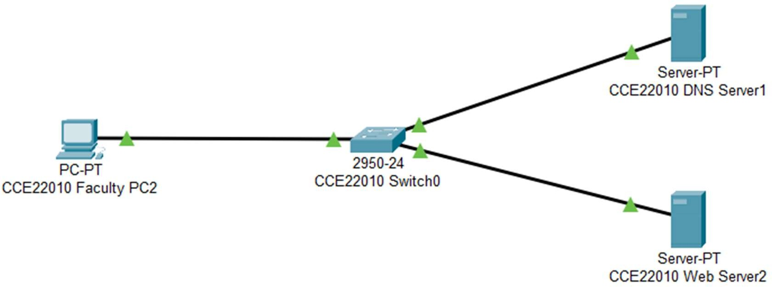
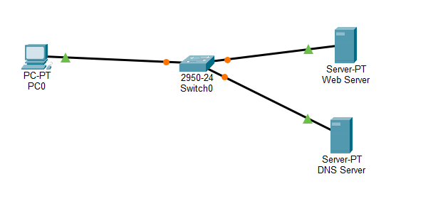

OUTPUT

- Configure IP Address of the PC

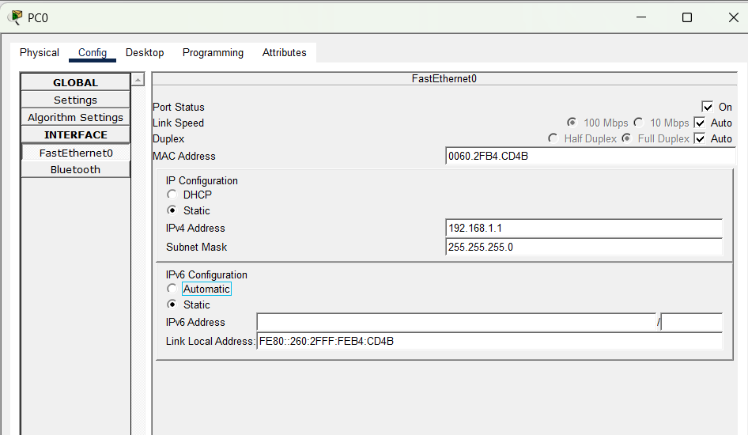
- Configure IP Address of the Web Server

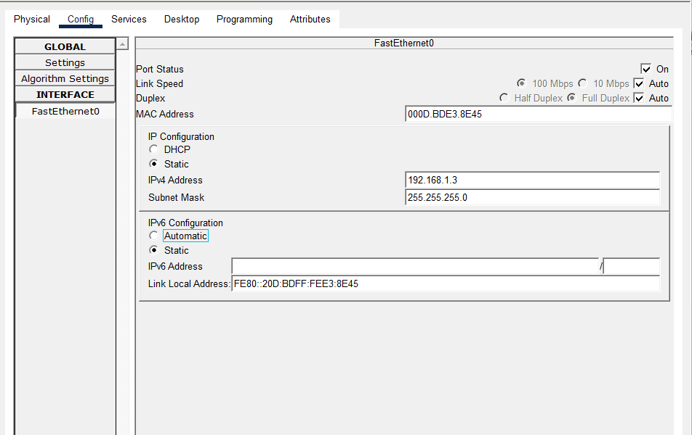

- Configure IP Address of the DNS Server

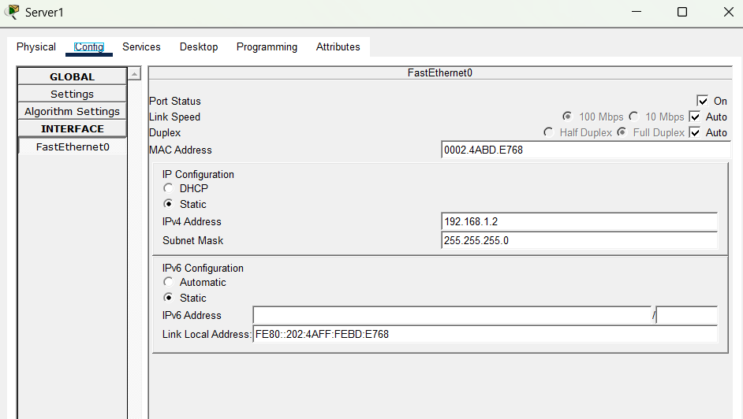

- Configure the DNS services: Web server record

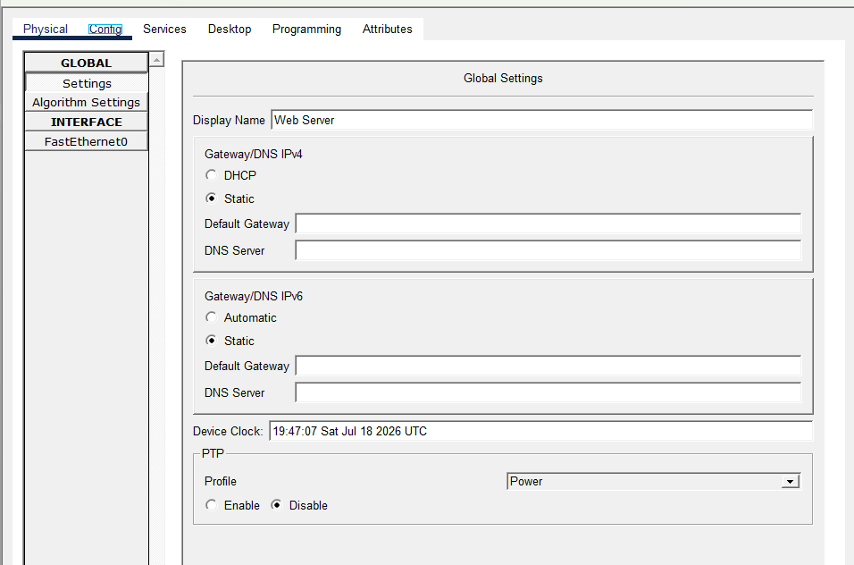

- Configure the DNS services: DNS server record

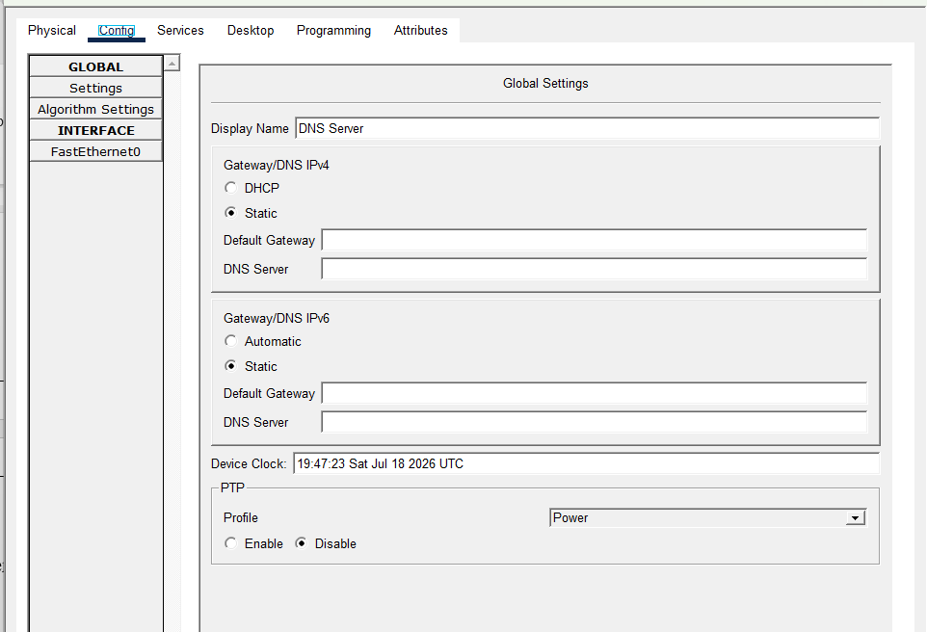

- Web Page Configuration: Web server record- amrita.com
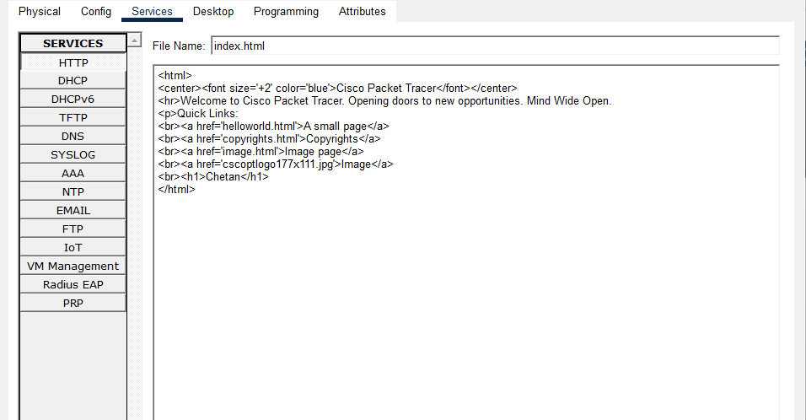

- Web Page Configuration: DNS server record- google.com

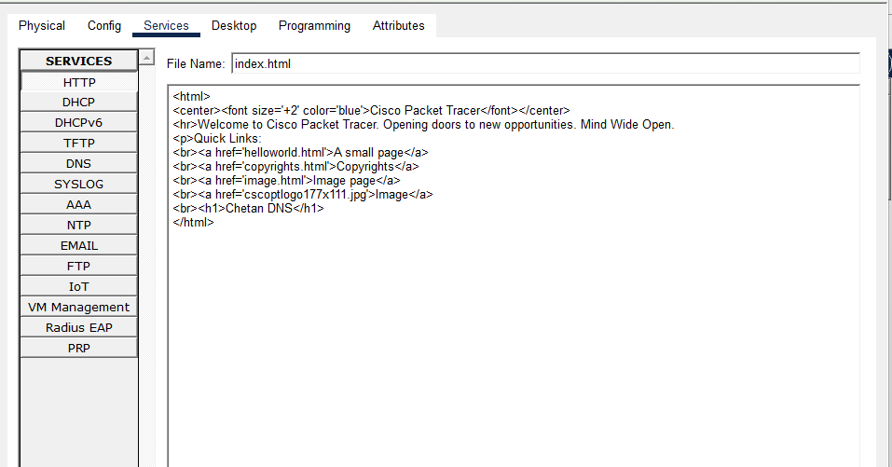
- Verify the working of Web server: access amrita.com from PC

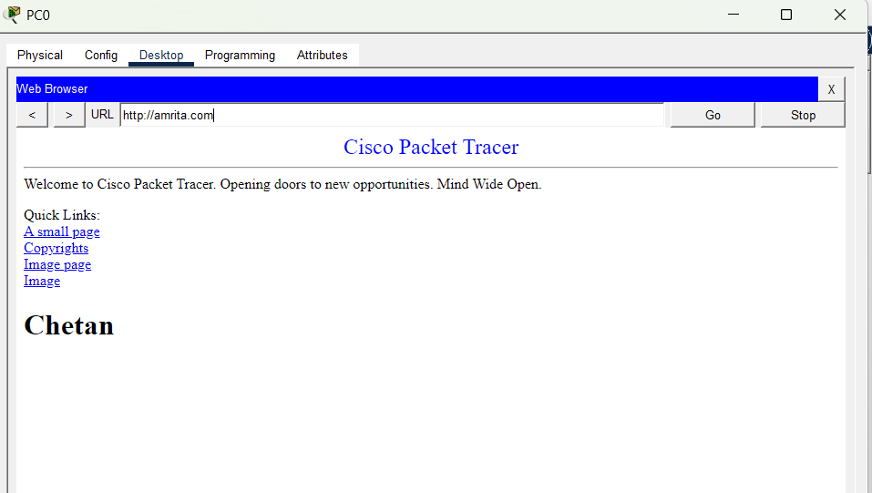

- Verify the working of DNS server: access google.com from PC

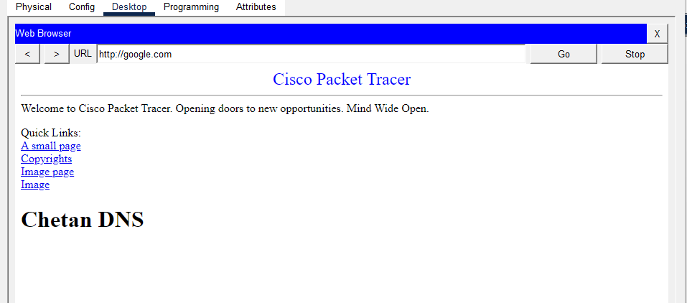

RESULT
The DNS Server and HTTP Web Server were successfully configured in Cisco Packet
Tracer. The web server was assigned the IP address 192.168.1.3, and the DNS server was
assigned 192.168.1.2. DNS A records were created to resolve amrita.com to the web
server and google.com to the DNS server. Both websites were successfully accessed
from the client PC using their domain names, confirming successful name resolution and
HTTP communication

INFERENCE
This experiment demonstrated the working of DNS and HTTP services in a local
network. The DNS server translated domain names into their corresponding IP addresses,
allowing users to access web resources using easy-to-remember hostnames instead of IP
addresses. The successful communication between the client, DNS server, and web
server verified correct IP addressing, DNS record configuration, and HTTP service
operation within the network

CONFIGURATION OF ROUTER AS DHCP SERVER AND IMPLEMENTATION OF WEB & DNS SERVER IN A NETWORK

AIM
To configure a DHCP server on a Cisco router for assigning IP addresses dynamically to the connected devices and to configure a DNS Server and an HTTP Web Server in the network using Cisco Packet Tracer.

SYSTEM AND SOFTWARE REQUIREMENTS
Software – Cisco Packet Tracer

Components used:
    - End Devices
      - 2 PC-PT
      - 2 Server-PT
    - Network Devices
      - Router 2911
- Switch 2950-24
    - Connections
      - Copper Straight-Through
      - Console cable

PROCEDURE

To configure a Cisco router as a DHCP server on a network using Cisco Packet Tracer and obtain an IP address automatically and to implement a Web & DNS server to access the respective webpage from connected devices within the network, follow these steps:

Step 1: Open Cisco Packet Tracer
1) Launch Cisco Packet Tracer on your computer.

Step 2: Add Devices to the Workspace
- Add two PCs:
  - Click on the "End Devices" icon in the bottom left corner.
  - Select "PC" and drag two PCs into the workspace.
- Add two servers:
  - Click on the "End Devices" icon in the bottom left corner.
  - Select "Server" and drag two servers into the workspace.
- Add a Router:
  - Click on the "End Devices" icon in the bottom left corner.
  - Select " Router " and drag a router (2901 series) into the workspace.
- Add a Switch:
  - Click on the "Switches" icon in the bottom left corner.
  - Select a switch (2950-24) and drag it into the workspace.

Step 3: Connect the Devices
- Select the Connection Tool:
  - Click on the "Connections" icon (lightning bolt) in bottom left corner.
- Connect the PC to the switch:
  - Click on a PC and then click on the switch to connect them with a Copper Straight-Through cable.
  - Repeat the process for the other PC.
- Connect the Server to the switch:
  - Click on a Server and then click on the switch to connect them with a Copper Straight-Through cable.
  - Repeat the process for the other server.
- Connect the Switch to the Router:
  - Click on the switch and then click on the router to connect them with a copper straight-through cable.
- Connect a PC to the router:
  - Click on a PC and then click on the router to connect them with a console cable.

Step 4: IP Configuration
- Router IP configuration:
  - Click on the router and navigate to the Config tab.
  - Select the interface connected to the PC (e.g., GigabitEthernet0/0).
  - Set the IP address and subnet mask:

IP Address: 192.168.1.1
Subnet Mask: 255.255.255.0
  - Check the box for "Port Status" to bring the interface up.

- Configure the web server
  - Open the web Server, navigate to Config, and Edit FastEthernet0 tab.
  - Choose Static to set IP address and subnet mask,

IPv4 Address: 192.168.1.2
Subnet Mask: 255.255.255.0
  - Check the box for "Port Status" to bring the interface up.
- Configure the DNS server
  - Open the DNS Server, navigate to Config, and Edit FastEthernet0 tab.
  - Choose Static to set IP address and subnet mask,

IPv4 Address: 192.168.1.10
Subnet Mask: 255.255.255.0
  - Check the box for "Port Status" to bring the interface up.

Step 5: Configure the Router as DHCP Through Command Line Interface:

- Select the router, navigate to CLI
- Enter privileged EXEC mode by typing:

enable
- Enter global configuration mode by typing:

configure terminal
- Exclude the specified range of IP addresses (192.168.1.1 to 192.168.1.5) from being assigned by the DHCP server:

ip dhcp excluded-address 192.168.1.1 192.168.1.5
- Create a new DHCP pool named "pool1" and enter DHCP pool configuration mode:

ip dhcp pool pool1
- Define the network range for the DHCP pool.

network 192.168.1.0 255.255.255.0
- Specify the DNS server IP address (192.168.1.10) that will be provided to DHCP clients.

dns-server 192.168.1.10
- Sets the default gateway (router) IP address (192.168.1.1) for DHCP clients:

default-router 192.168.1.1
- Exit the DHCP pool configuration mode

Exit

Step 6: Configure the DNS Server
- Click on the DNS Server, go to the Services tab, and select DNS.
- Turn on the DNS service.
- Add a new A record for the web server:

Name: amma.com Address: 192.168.1.2
- Add and save the configuration.
- Add a new A record for the DNS server:

Name: yahoo.com Address: 192.168.1.10
- Add and save the configuration.

Step 7: Webpage Configuration:
- Web Server:
  - Click on the Server-PT device to open its configuration window.
  - Navigate to Services, open HTTP, and ensure the service is ON.
  - Make any necessary changes to the webpage by editing the index.html.
  - Navigate to the Config tab and Edit the global settings
  - Name the server (ex: Web Server)
- DNS Server:
  - Click on the Server-PT device to open its configuration window.
  - Navigate to Services, open HTTP, and ensure the service is ON.
  - Make any necessary changes to the webpage by editing the index.html.
  - Navigate to the Config tab and Edit the global settings
  - Name the server (ex: DNS Server)

Step 8: Verify the Configuration and obtain IP address for the PCss Through graphical-user interface:
- On the PCs, go to the Desktop tab, open the IP Configuration, and set it to DHCP.
- Verify that the PC obtains an IP address from the router.

Through Command Line Interface:
- Type ipconfig /release to release the IP address back to the DHCP pool, disconnect from the network and prepare for obtaining a new IP address.
- Type ipconfig /renew to re-establish network connectivity and get a new IP address from the DHCP pool after releasing the previous one.

Step 9: Verify the working of Web and DNS servers
- Web service:
  - On the PCs, go to the Desktop tab, open the Web Browser.
  - Enter the URL: amma.com and verify that the web page from the Web Server is displayed.
- DNS service:
  - On the PCss, go to the Desktop tab, open the Web Browser.
  - Enter the URL: yahoo.com and verify that the web page from the DNS Server is displayed.

NETWORK TOPOLOGY DIAGRAM

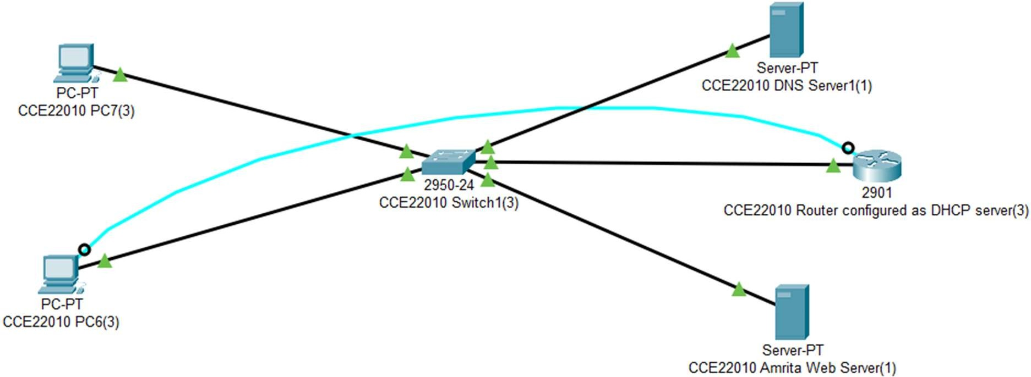
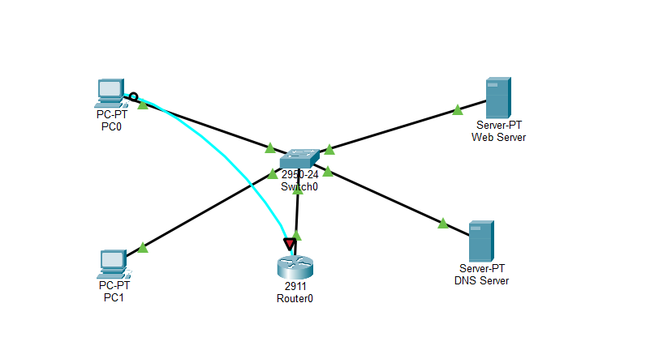
OUTPUT
- Configure IP Address of Router:
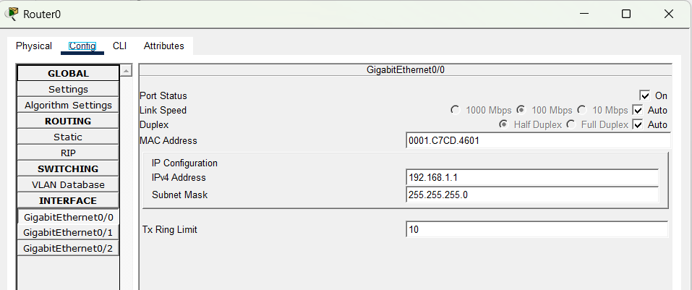

- Configure IP Address of the Web Server
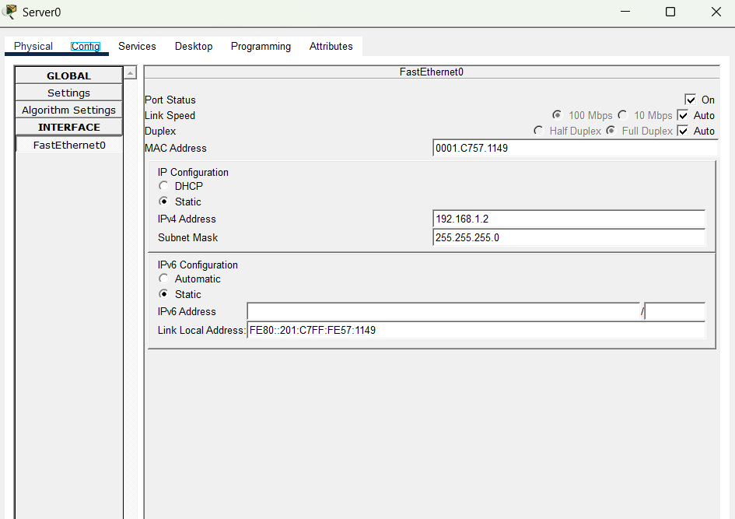

- Configure IP Address of the DNS Server

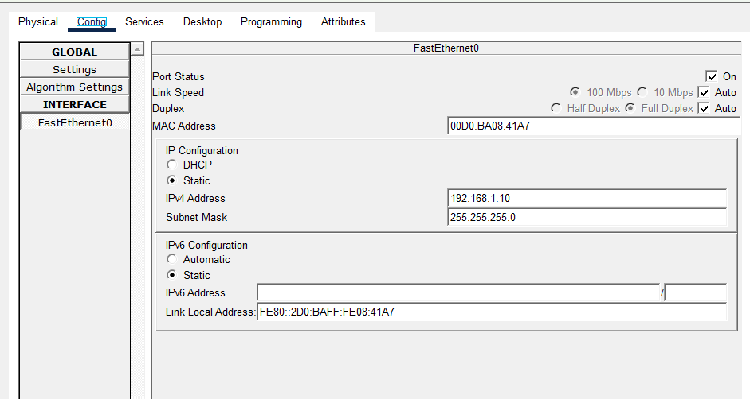

- Configure the Router as DHCP Through Command Line Interface:

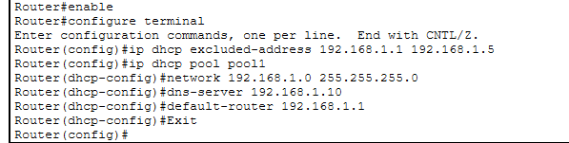
- Configure the DNS services: Web server record

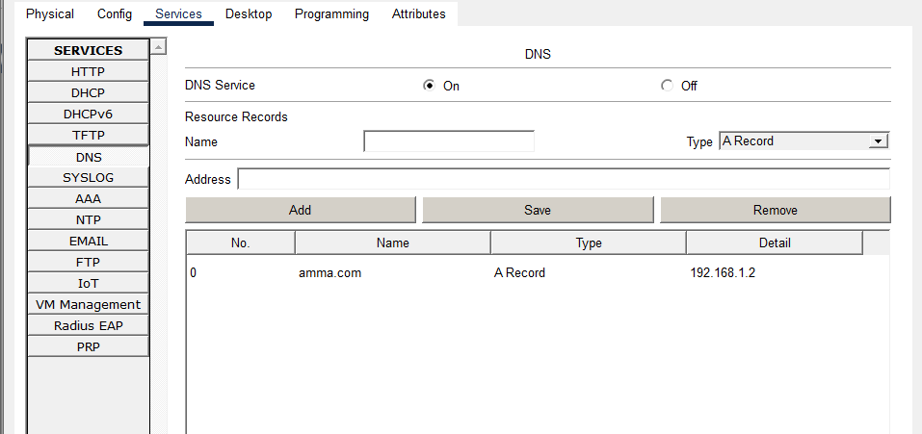

- Configure the DNS services: DNS server record
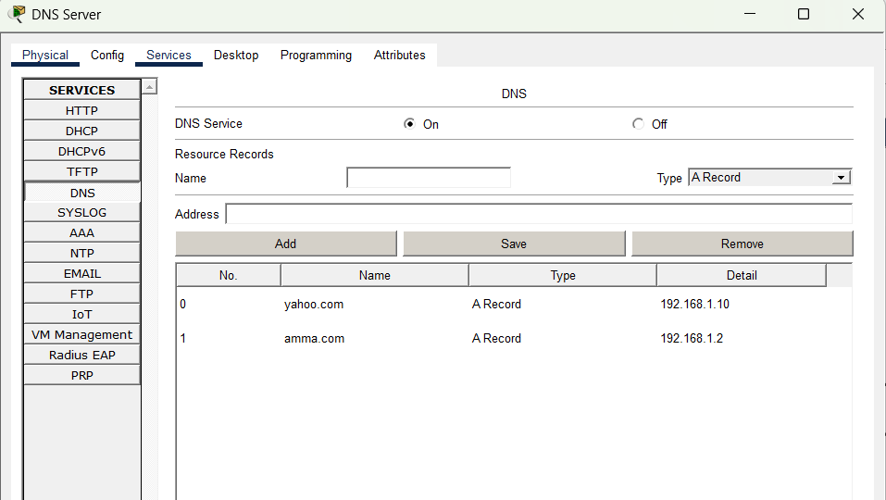

- Web Page Configuration: Web server record- amma.com
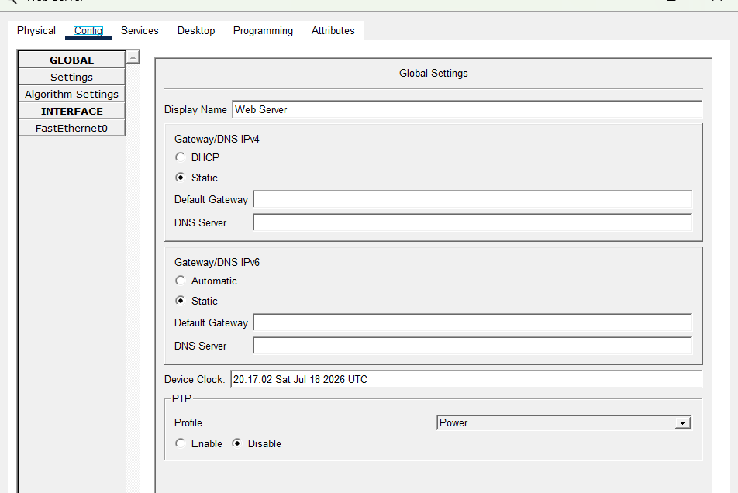

- Web Page Configuration: DNS server record- yahoo.com

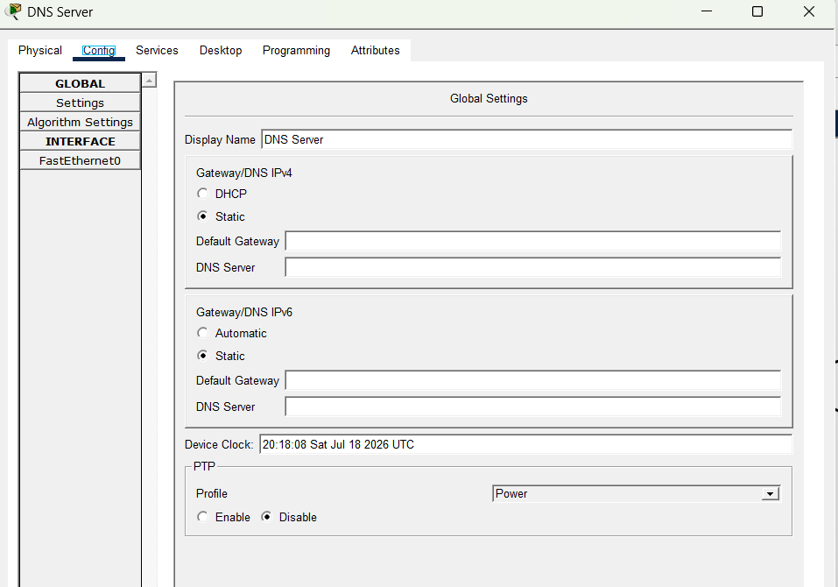

- Verify the Configuration and obtain IP address on any PC:
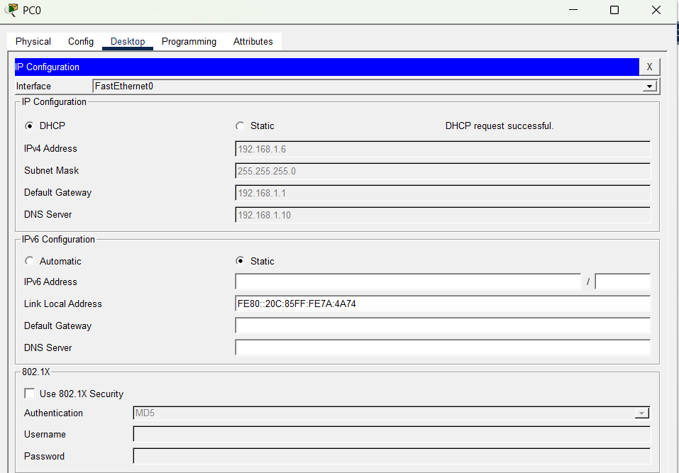
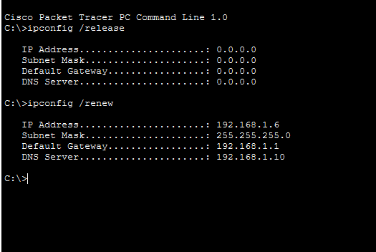

- Verify the working of Web server: access amma.com from PCs
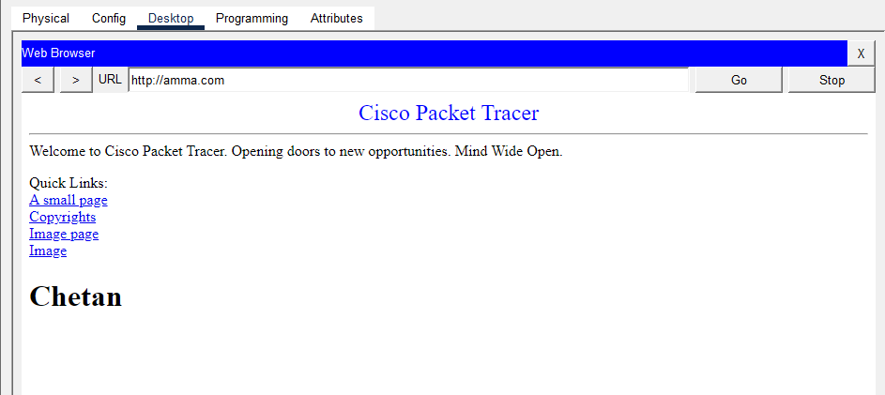

- Verify the working of DNS server: access yahoo.com from PCs

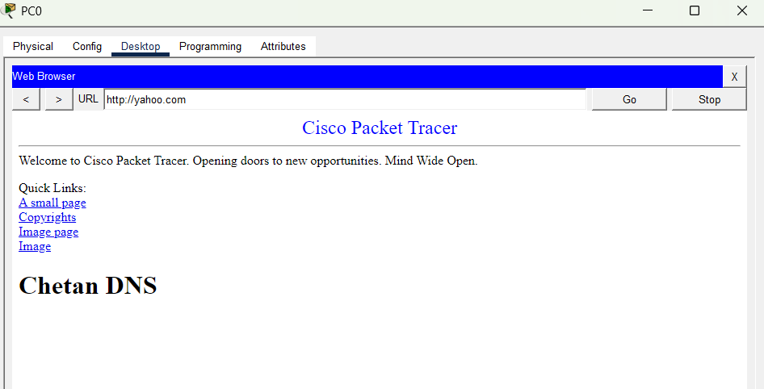

RESULT
We successfully configured a Cisco router to act as a DHCP server. The router dynamically assigned IP addresses to the connected devices within the defined IP range, and implemented a web server to access a webpage from connected devices within the network, ensuring efficient IP address management in the network.
- First IP Configuration: obtain an IP address automatically via DHCP for Faculty PC.
- Release of IP address back to the DHCP pool using ipconfig /release and re-establish network connectivity to get a new IP address using ipconfig

/renew:

- Access of webpage from the connected devices in the network: yahoo.com

- Access of webpage from the connected devices in the network: amma.com

INFERENCE:

The experiment demonstrated the integration of DHCP, DNS, and HTTP services in a network using
Cisco Packet Tracer. The router successfully functioned as a DHCP server by dynamically assigning
IP addresses, subnet mask, default gateway, and DNS server details to client devices. The DNS server
correctly resolved domain names to their respective IP addresses, enabling clients to access the HTTP
web server using hostnames instead of IP addresses. This experiment highlighted how DHCP
simplifies network administration while DNS and HTTP services improve accessibility and usability
within a network

Lab Scenario: Launching an Intranet Portal for a College Campus

Scenario Title:
“Deploying an Automated Web and DNS Service with Dynamic IP Allocation for Campus Intranet”

Background:
Your college is planning to launch an internal web portal called intranet.mycollege.edu for students and staff. The web portal will provide access to notices, results, course materials, and faculty contact information.
As part of the IT team, you are assigned to set up the infrastructure to:
- Dynamically assign IP addresses to all devices in the lab using DHCP
- Host the web portal on an HTTP Web Server
- Allow users to access the portal by hostname using a local DNS server
- Ensure that the entire network functions smoothly under a router-managed configuration
You are required to implement and test the following in a simulated or real environment:

Part A: DNS and HTTP Web Server Setup

Task:
- Set up an HTTP Web Server on a machine with the homepage content:
Welcome to the MyCollege Intranet Portal.
- Set up a DNS Server that:
  - Resolves the domain name intranet.mycollege.edu to the IP address of the web server.
- Test the setup by:
  - Accessing intranet.mycollege.edu from another machine in the network via a browser or curl.

Answer the following:
- Q1: What IP address is assigned to the web server, and what domain name is configured in the DNS?
Web Server IP: 192.168.1.3
Configured Domain: amrita.com

- Q2: Provide a screenshot or output showing successful name resolution using nslookup or dig.
nslookup amrita.com
Server: 192.168.1.2
Address: 192.168.1.2
Name: amrita.com
Address: 192.168.1.3

- Q3: Provide evidence that the web page is accessible using the domain name, not just the IP.
The webpage was successfully accessed by entering http://amrita.com in the web
browser. The DNS server resolved the domain name to the web server IP address
(192.168.1.3), and the webpage loaded successfully without directly entering the IP
address.

Part B: Router DHCP Configuration and Integration

Task:
- Configure a Router (real or simulated, e.g., in Cisco Packet Tracer) to act as a DHCP server that assigns:
  - IP Range: 192.168.20.100 – 192.168.20.200
  - Subnet Mask: 255.255.255.0
  - Default Gateway: 192.168.20.1
  - DNS Server: IP of your configured DNS server
- Connect multiple client PCs to the router and configure them for dynamic IP allocation.
- Ensure that clients can:
  - Automatically receive IP addresses via DHCP
  - Resolve the domain name intranet.mycollege.edu
  - Access the web server successfully

Answer the following:
- Q4: What IP addresses did the clients receive from the DHCP server?
1 – 192.168.1.6
2 – 192.168.1.7
- Q5: What DNS IP address was assigned to the clients? Was it correct?
192.168.1.10
Yes, correct
- Q6: Show how a client successfully accessed the portal using the domain name.
The client successfully accessed the web server using the domain name:
http://amma.com
The DNS server resolved amma.com to 192.168.1.2, and the webpage was displayed
successfully in the web browser, confirming proper integration of DHCP, DNS, and HTTP
services

Bonus Challenge (Optional):
Simulate a situation where the DNS server is unreachable and explain how that affects access to the portal. What troubleshooting steps would you take?
Impact of DNS Server Failure
When the DNS server is unavailable, it cannot translate a website's domain name (such as intranet.mycollege.edu or amma.com) into its corresponding IP address. Because of this:
- Users cannot open websites by typing their domain names.
- Browsers display messages like "DNS Server Not Responding," "Server Not Found," or "DNS Resolution Failed."
- If the web server's IP address is known (for example, 192.168.1.2), users can still access the website directly using http://192.168.1.2, as long as the web server is functioning properly.

Steps to Troubleshoot DNS Failure
- Check DNS Service: Ensure that the DNS service is running on the DNS server.
- Verify Network Configuration: Confirm that the DNS server has the correct IP address and is properly connected to the network.
- Validate DNS Records: Make sure the required A Records (e.g., amma.com → 192.168.1.2) are correctly configured.
- Inspect DHCP Settings: Verify that client systems have received the correct DNS server address through DHCP.
- Test Network Connectivity: Use the ping command to check whether the DNS server is reachable.
- Verify Name Resolution: Run the nslookup command to confirm that domain names are resolving to the correct IP addresses.
- Check Network Devices: Inspect switches, routers, and their interfaces to ensure there are no connectivity issues.
- Restart or Reconfigure DNS: If problems persist, restart the DNS service or correct any configuration errors.

Conclusion
The simulation demonstrates that the DNS server is responsible only for converting domain names into IP addresses. A DNS failure prevents users from accessing websites through their domain names, even though the web server itself may still be active. Direct communication using the server's IP address remains possible. Therefore, maintaining a properly configured and continuously available DNS service is essential for smooth and reliable network communication.

